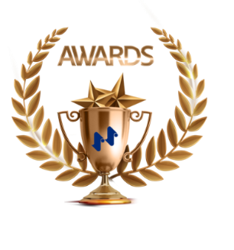 **World Corrugated Awards 2025**

|  |  |  |  |
| --- | --- | --- | --- |
| **First Name** |  | **Last Name** |  |
| **Gender** |  | **Company** |  |
| **BusinessNature** |  | **Department** |  |
| **Job Position** |  | **Tel** |  |
| **E-mail** |  | **Address** |  |
| **Awards** | **Lightweight Awards**  □ Best Lightweight Design of the Year □ Best Lightweight Material of the Year  □ Best Lightweight Solution of the Year  **Business Management Awards**  □ Supply Chain Management Excellence of the Year  □ Intelligent Production of the Year  □ Business Transformation of the Year  **Social Value Awards**  □ Outstanding People in the Industry of the Year  □ Best ESG Demonstration of the Year | | |
| **Requirements for Nomination Materials** | **Format**：**Products + Pictures +** **Description (Up to 500 words)** | | |
| **Declaration** | 1. I guarantee that I have full and complete intellectual property rights over the entries and that I will not infringe on the patents, copyrights, trademarks and other intellectual property rights of any other person; if any infringement occurs, it is not the responsibility of the organiser.  2、I agree to the promotion, exhibition, proofing, production and use of the entries by the organisers. | | |
| **Signature：_**____________________ | | | |